Q1.Insert elements into stack and display it.
#include<stdio.h>
#include<conio.h>
#include<stdlib.h>
#define SIZE 4
int top=-1,inp_array[SIZE],i;
void push();
void show();
int main()
{
int choice;
while(1)
{
printf("\nPerform operations on stack: ");
printf("\nPush elemnt\n2 show element\n3.end");
printf("\nEnter choice: ");
scanf("%d", &choice);
switch(choice)
{
case 1:
push();
break;
case 2:
show();
break;
case 3:
exit(0);
default:
printf("\nInvalid choice ");
}
}
}
void push()
{
int x;
if(top==SIZE-1)
{
printf("\noverflow ");
}
else{
printf("Enter element to added: ");
scanf("%d", &x);
top=top+1;
inp_array[top]=x;
}
}
void show()
{
if(top==-1)
{
printf("\nunderflow");
}
else{
printf("elemnts present : ");
for(i=top;i>=0;--i)
printf("%d\n", inp_array[i]);
}
}

output:
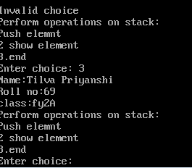

Q2.Delete elemnt from stack.
/*
Name:Tilva Priyanshi
Roll no:69
class:fy 2a
*/
#include<stdio.h>
#include<conio.h>
#include<stdlib.h>
#define SIZE 4
int top=-1,inp_array[SIZE],i;
void pop();
void show();
int main()
{
int choice;
printf("\nName:Tilva Priyanshi\n2Roll no:69\n3class:2a ");
while(1)
{
printf("\nPerform operations: ");
printf("\npop\n2show\n3.end");
printf("\nEnter choice: ");
scanf("%d", &choice);
switch(choice)
{
case 1:
pop();
break;
case 2:
show();
break;
case 3:
exit(0);
default:
printf("\nInvalid choice ");
}
}
}
void pop()
{
if(top==-1)
{
printf("\nunderflow ");
}
else
{
printf("\npopped element: %d",inp_array[top]);
top=top-1;
}
}
void show()
{
if(top==-1)
{
printf("\nunderflow ");
}
else{
printf("Elemnts present stack: \n");
for(i=top;i>=0;--i)
printf("%d\n",inp_array[i]);
}
}

Output: 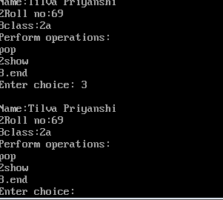

Q3.Insert element into queue and display.
#include<stdio.h>
#include<conio.h>
#include<stdlib.h>
#define SIZE 4
int maxsize,i;
void insert();
void display();
int front=-1,rear=-1;
int queue;
int main()
{
int choice;
while(choice!=4)
{
printf("Enqueue operation: \n");
printf("exit: \n");
printf("Enter choice: ");
scanf("%d", &choice);
switch(choice)
{
case 1:
insert();
break;
case 2:
display();
break;
case 3:
exit(0);
break;
default:
printf("invalid choice: ");
}
}
return 0;
}
void insert()
{
int item;
printf("\nEnter element: a");
scanf("\n%d", &item);
if(rear==maxsize-1)
{
printf("overflow: ");
return;
}
if(front==-1&&rear==-1)
{
front=0;
rear=0;
}
else
{
rear=rear+1;
}
queue[rear] = item;
printf("\nvalue inserted: ");
}
void display()
{
int i;
if(rear==-1)
{
printf("\nEmpty queue: ");
}
else
{
printf("printing values: ");
for(i=front;i<=rear;i++)
{
printf("\n%d\n", queue[i]);
}
}
}

Q4.Delete element from queue and display it.

#include<stdio.h>
#include<conio.h>
#include<stdlib.h>
#define maxsize 4
int i;
void delet();
void display();
int front=-1,rear=-1;
int queue[maxsize];
int main()
{
int choice;
while(choice!=4)
{
printf("Enqueue operation: \n");
printf("exit: \n");
printf("Enter choice: ");
scanf("%d", &choice);
switch(choice)
{
case 1:
delet();
break;

case 2:
display();
break;
case 3:
exit(0);
break;
default:
printf("invalid choice: ");
}

void delet()
{
int item;
if(front==-1||rear)
{
printf("underflow: ");
return;
}
else
{
rear=rear+1;
}
item=queue[front];
if(front==rear)
{
front=-1;
rear=-1;
}
else{
front=front+1;
}
printf("\nvalue deleted");
}
}

void display()
{
int i;
if(rear==-1)
{
printf("\nEmpty queue: ");
}
else
{
printf("printing values: ");
for(i=front;i<=rear;i++)
{
printf("\n%d\n", queue[i]);
}
}
}

